TAFIQ AKHIR
Licensed Menopause Specialist
Speaker + Healthy Aging Advocate
Regain control of your body by repairing the root cause of your
hormone, health, and weight management issues.

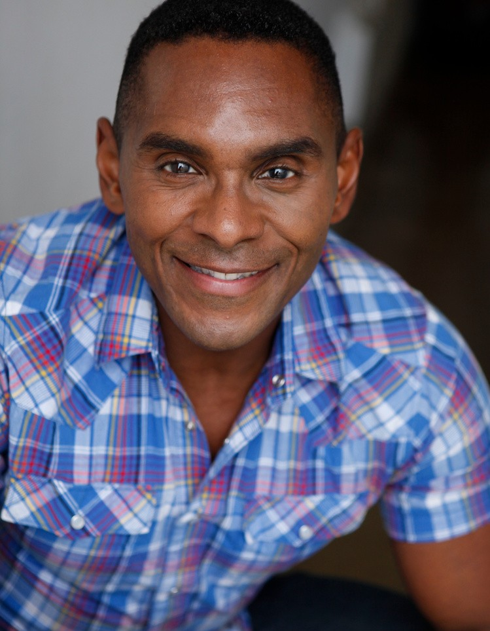Hello, and thank you for your interest in having Tafiq Akhir as one of your featured speakers at your upcoming event, conference, webinar, radio show, or podcast!

This document contains all the information you will need to make the decision to book Tafiq Akhir to speak at your event, as well as find all the info you need to promote and market his talk, including bios, talk descriptions, logo, headshots, interview questions, social links, references and more.

There are many videos of Tafiq online, some of the large presentations, some small, and some quick video tips so you can see examples of his candor. For videos, go to www.tafiq.com/blog or www.youtube.com/tafiqtv

Tafiq can sell or not sell from the stage as the host prefers; however, we always ask that, at minimum, we can hold a drawing and/or have a display table in the room during the entire event as well to offer books and free resources (virtual too). We are open to discussing opportunities to offer the event coordinator a commission for anything we sell. We also typically promote your event to our email list and social following for more reach.

Why Choose Tafiq as a speaker for your event?

Tafiq always gives high-quality, highly effective, and time-efficient informative, motivating, engaging, and fun presentations for all audiences. In Tafiq Akhir’s presentations, he typically interacts and engages with the audience, asking questions, getting them to connect with one another, and taking notes on the material he covers. He’s also been known to ‘spot coach’ some attendees during his presentations.
Thank you, we look forward to working with you! Betty M.
Virtual Assistant
Please contact me with any questions or concerns: 323-413-2187
customercare@tafiq.com

TAFIQ AKHIR
Licensed Menopause Specialist
Speaker + Healthy Aging Advocate
Regain control of your body by repairing the root cause of your
hormone, health, and weight management issues.

SHORT SPEAKER BIO

Tafiq Akhir , is a Licensed Menopause Specialist, Speaker, and Healthy Aging Advocate. Tafiq specializes in helping women regain control of their bodies by repairing the root cause of menopause and another hormone, health, and weight management issues they have struggled with for years. And provides menopause in the workforce and healthy aging talks and programs for corporations, organizations and groups.

Tafiq has over 20 years of experience as one of LA's most trusted health and fitness experts, and for over 15 of those years, he has provided hormone, health, and weight management coaching for midlife women, so they could finally reverse illness, and improve health, boost their confidence, get their sexy back, and feel better than they have in years

150-WORD SPEAKER BIO
Tafiq Akhir helps menopausal women regain control of their bodies by repairing the root cause of the hormone, health, and weight management issues; so they can finally feel healthy and energetic while improving their memory, boosting confidence, improving their mood, getting their sexy back, and falling in love with what you see when you look in the mirror.

For companies, organizations, and groups he provides keynotes, workshops, eLearning, and onsite health and wellness training programs for menopause in the workforce, how to manage menopause, body confidence as you age, and more to promote inclusion, productivity, symptom relief, healthy weight loss, and a supportive working environment.

You can also find a variety covering a variety of hormone, health, and weight management videos and interview specifically for the needs of midlife women and men on his streaming channel, Tafiq TV, to help restore your health, reshape your body and renew your life.

TAFIQ AKHIR
Licensed Menopause Specialist
Speaker + Healthy Aging Advocate
Regain control of your body by repairing the root cause of your
hormone, health, and weight management issues.

LONG SPEAKER BIO
Tafiq Akhir (aka Mr. Menopause) is a Licensed Menopause Specialist, Speaker, Host, and Healthy Aging Advocate. Tafiq specializes in helping women regain control of their bodies by repairing the root cause of menopause and many other hormone, health, and weight management issues they have struggled with for years. So they finally feel healthy, happy, and hopeful that they can get back a life they didn't believe they could have again.

Tafiq has over 20 years of experience as one of LA's most trusted health and fitness experts. For over 15 of those years, he has provided hormone, health, and weight management coaching for midlife women, so they could finally reverse illness, improve health, boost their confidence, get their sexy back, and feel better than they have in years.

Tafiq provides keynotes, workshops, eLearning programs, and onsite health and wellness training for businesses, groups, and organizations. His topics include:

Body confidence as you age. Menopause in the workplace.
Customized programs to support optimal health. And more...

Tafiq is a licensed menopause specialist with the Menopause Experts Group and an executive contributor to Brainz Magazine. In addition, he has numerous continued education certificates of completion, including Understanding Hormones, How Hormones and Metabolism Change Training For Amen, and Balancing Hormones For Optimal Weight- loss, to name a few.

He also has nationally accredited certifications as a Nutrition & Wellness Consultant, Personal Fitness Chef, Health Coach, and Group Exercise Instructor.

When Tafiq is not helping to restore health, reshape bodies, and renew lives, he enjoys spending quality time with his spouse Darryl and their two fur babies, Jasper and Lewie. He is also a proud member of the Board of Directors for the Boys & Girls Club of Hollywood and enjoys doing anything related to the creative arts, whether painting, designing, or taking a dance class.

TAFIQ'S HEADSHOTS + PROMOTIONAL IMAGES
CONTACT DETAILS
tafiq@tafiq.com
www.TAFIQ.com
+310-591-9064
instagram.com/tafiqsphysiques
facebook.com/tafiqsphysiques
youtube.com/tafiqtv
linkedin.com/in/tafiqakhir
TAFIQ AKHIR
Licensed Menopause Specialist Speaker + Healthy Aging Advocate

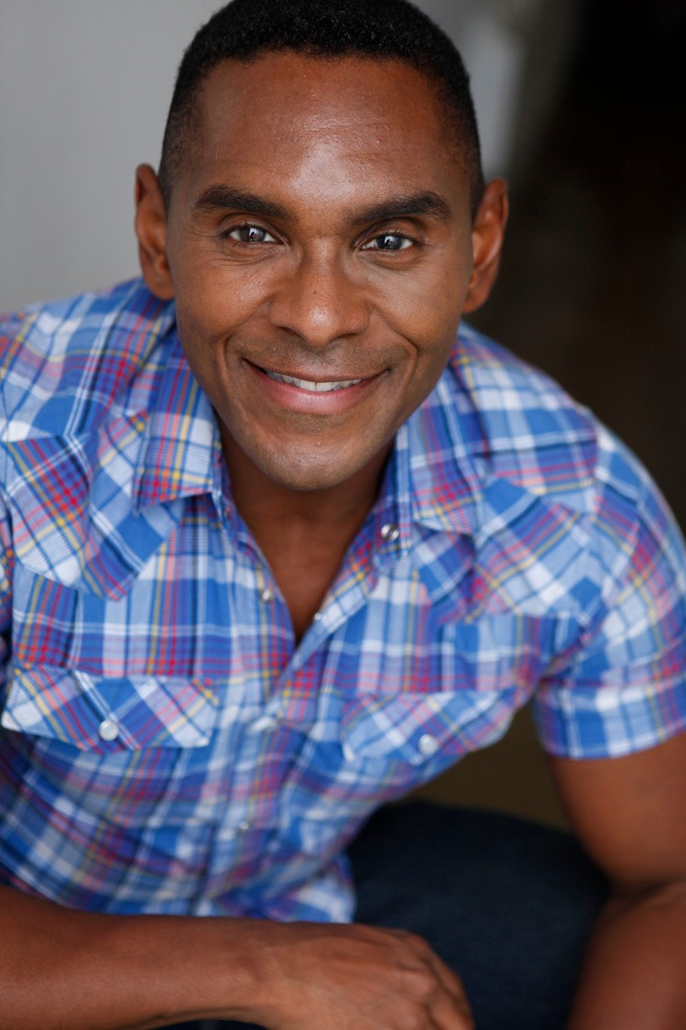
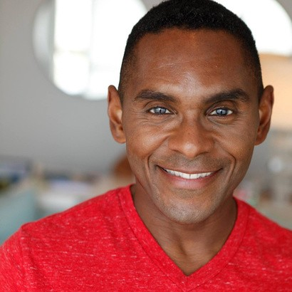
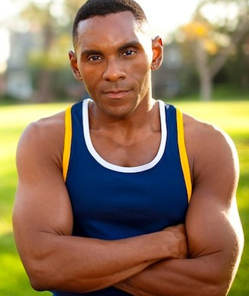

PROPOSED SPEAKING TOPICS
The following is a list of Presentation Topics that Tafiq Akhir, founder and CEO of award-winning health and wellness company Tafiq's Physiques, speaks on to groups, organizations, and businesses in general. Tafiq can also customize a speaking experience for your event, or you can choose from one of his popular signature topics.
All of these talks are best as a keynote or 90-minute presentation; however, Tafiq offers 30, 45, and 60-minute presentations.
Tafiq always provides highly effective, time-efficient, and engaging presentations that are motivating, inspirational, and fun for all audiences. Tafiq's presentations are suitable for large corporations and executives, as well as small groups and intimate retreat settings; however, Tafiq can customize a speaking experience for your event no matter the size.

SPEAKING TOPIC #1

How To Manage Menopause In The Workforce
Nearly 20% of American women experiencing menopause have quit their jobs or are thinking about doing so because of their symptoms. Since 77% of women don't even realize they're in menopause, it's also believed that this percentage may be substantially higher.

How would you like to be able to manage your menopause symptoms better and have the resources and support you need at work to do so in order to keep your job as an employee or retain valuable talent as an employer?
In this presentation, you'll learn the following:
Rarely known facts about menopause and its effect on work, productivity, collaboration, and more to understand better what is happening during this stage of a woman's life.
How to provide the support needed within the organization to prevent the loss of jobs and valued talent.
How to openly discuss menopause issues without fear, embarrassment, or discomfort for employees or employers.
The importance of having a menopause policy added to the organization's wellness plan.
Different onsite and offsite coaching options to help minimize, reverse and even prevent symptoms from interfering with work and life in general.

SPEAKING TOPIC #2

How To Restore Body Confidence As You Age

It’s no big surprise that as we get older, our bodies change. It’s the natural progression of the aging process. It should also be no big surprise that you can control how you age. You can age poorly, or you can age amazingly. The key to aging amazingly is what most people do wrong.

The aging process has many women over 40 feeling as though they’re losing control of their bodies and that, physically, everything is going downhill. Statistics also show that 83% of women say social media negatively affects their self-esteem and 39% of women compare themselves to the women they see in excellent shape online and in magazines.
In this presentation, you will learn the following:
Why do health and physical activity tend to decline as we age?
How to evaluate the effectiveness of your nutrition choices as you age. The most crucial part of exercising as you age.
Simple solutions to reshape your body and restore your health at 40 and beyond

SPEAKING TOPIC #3

How To Repair The Root Cause Of Menopause Symptoms

Did you know there are more than 30 life-altering symptoms associated with menopause? More recently, it’s been noted that there can be up to 60 symptoms associated with menopause. It’s not just hot flashes, belly fat, and mood swings as so many people believe.

Women with menopause are also being misdiagnosed and treated for everything from fibromyalgia and depression to rheumatoid arthritis and dementia and still getting little, if any relief from their symptoms.
In this presentation, you will learn the following:
The four primary areas of metabolic distress that negatively affect hormones, health, and weight most often during menopause.
Why the diets and workouts that used to work to get results are no longer working?
A four-phase process to eliminate symptoms, reverse illness, shed stubborn body fat, and get back a life you may not think you could have again.

SPEAKING TOPIC #4

How To Go From Sickness To Fitness At 40 And Beyond

There is a broad spectrum between sickness and fitness. Sickness, as you know, is when your body and health are not in good condition. Many illnesses, diseases, and physical states can be defined as sickness. Right in the middle is wellness, where a person feels well. That would be - not bad, not good, but somewhere in the middle, just about average. On the fitness end of the spectrum is where you're physically, mentally, and emotionally healthy and fit.

In this presentation, I'm sharing my own personal journey of reversing a pre-diabetes diagnosis, eliminating the need for liver medication, naturally losing 40 pounds, and fully recovering from a stroke.
In this presentation, you will learn the following:
What metabolic health is and the importance of improving metabolic health based on your individual needs.
How to make food choices based on your health and wellness needs. How to make physical activity a consistent part of your daily life.
How to realistically live a healthier lifestyle to promote optimal health and vitality.

SPEAKING TOPIC #5

How To Maintain A Healthy Relationship During Menopause

Women initiate more than 60 percent of divorces during their menopausal years, according to AARP. What's worse is that most women don’t even realize they are in menopause, therefore, are unaware that the mood swings, depression, anxiety, lack of confidence, and lack of libido that are the cause of many of their marital issues may be primarily caused by the menopause symptoms they are experiencing.

Menopause is more than a women's health issue; it is a women's life issue. It affects her mentally, physically, and emotionally which means it will affect her relationships, job, and health.
In this presentation, you will learn the following:
How menopause affects women mentally, emotionally, and sexually.
The importance of openly discussing menopause, especially with significant others and family members
How family and friends can be a champion and support system so you are not suffering through menopauses alone.

TAFIQ AKHIR

Licensed Menopause Specialist Speaker + Healthy Aging Advocate
www.TAFIQ.com 310-591-9064 TAFIQ@TAFIQ.COM

SPEAKING TOPIC #6

CREATING THE PATH FOR HEALTHY AGING
The needs of your body change during every stage of life – physically, mentally, and emotionally. During these stages, the key to optimal health and vitality is to shift and adjust based on what your body needs to thrive.

The state of your metabolic health as you age depend on whether you work with the changes happening within your body to maximize your well-being for long-term success or if you fight and resist the changes happening in your body and promote tension, resistance, breakdown, and fatigue resulting in illness and poor health.
In this presentation, you will learn the following:
How to maximize your metabolism through functional nutrition during every stage of life.
The best types of physical activity for strength and longevity during each stage of life.
How to optimize your life for long-term physical, mental and emotional health and vitality.

ADDITIONAL SPEAKING OPTION

GET A CUSTOMIZED SPEAKING EXPERIENCE
Tafiq is well-versed in several wellness topics, including nutrition, fitness, healthy living, women's health, men's health, sleep improvement, stress management, healthy habit change, and more. If you want something targeted exclusively to your audience, Tafiq can customize a speaking experience, especially for your event.

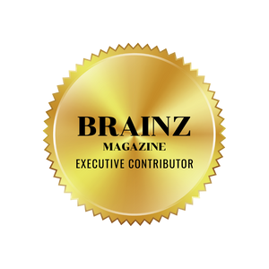TAFIQ AKHIR
AS SEEN ON

Licensed Menopause Specialist Speaker + Healthy Aging Advocate
www.TAFIQ.com 310-591-9064 TAFIQ@TAFIQ.COM

"Tafiq's presentation on "How To Repair The Root Cause Of Your Menopause Symptoms" was excellent.
In it, Tafiq gave a clear explanation of various causes for our menopause symptoms in a well-laid- out, easy-to-understand explanation.
Further, as a fellow health coach, I can confidently write that Tafiq knows his stuff and can assist women with menopause issues.
When working with women who want to permanently release weight, Tafiq doesn't focus on the weight but instead, he puts his attention on the body healing itself. Once the body is healed, the weight naturally comes off, and the body starts to thrive!
I fully recommend Tafiq to women who are experiencing menopause symptoms.”
Oralia Acosta, Health Coach

"There was so much good information I would go to this presentation a second time. Tafiq covered a variety of topics including nutrition, the critical role of sleep, listening to your body, and the difference between high and low intensity exercise."
M.L., LAX
"I have had the pleasure of partnering with Tafiq Akhir for the past 6 years. I am constantly blown away by his depth and breadth of knowledge about health, nutrition, hormonal balance, metabolism, and fitness. We always receive exceptional feedback from the participants of his wellness presentations, telling us what a great presenter he is, and how beneficial the information is that he shares. Tafiq is professional, reliable, and an absolute pleasure to work with! I am a huge fan of everything he does and highly recommend him as a speaker, coach, and trainer."
Nicole Mixdorf, Chief Wellness Officer,
Balance by Nature

"Tafiq's approach and professionalism is top notch. He has definitely been one of the most comprehensive health and wellness coaches in LA! If you are looking for an A + presentation and nutrition and wellness guidance, I highly recommend him. I approve this comment."
Pernell W., Humam Resources

TAFIQ AKHIR
CLIENTS + AUDIENCE FEEDBACK
Beverly
connection

Licensed Menopause Specialist Speaker + Healthy Aging Advocate
www.TAFIQ.com 310-591-9064 TAFIQ@TAFIQ.COM

List of Tafiq's Speaking Clients

- Speaker Con Conference (In-Person)
- Balance By Nature (In-Person & Virtual)
- LAX (In-Person & Virtual)
- Westfield Century City Mall (In-Person & Virtual)
- Beverly Connection (In-Person)
- Hooper, Lundy, and Bookman (In-Person & Virtual)
- Health Made Simple (In-Person)
- Edmunds (In-Person)

Tafiq's Television, Virtual & Radio Appearances

- Balancing Act, An Expert Look At Fitness & Metabolic Health, Interview 2022
- 1MD Nutrition, Board-Certified Doctors Answer Your Top Healthy Aging + Heart Health Questions, Interview 2022
- Guru Reels, Finding The Right Fitness Studio For Your Personal Health and Fitness Needs, 2021
- At Home w/ Victoria, Summer Fitness & Nutrition, 2016
- Late Night Rendezvous: The Final Count Down, Healthy Living, 2016
- Two Smart Dumbbells, TXT: Tafiq's Extreme Tabata promotion, 2012

Memberships & Organizations Tafiq Is A Part Of

- Boys & Girls Club of Hollywood, Board of Directors
- Menopause Experts Group
- Online Trainer Academy
- International Speaker Network
- SpeakerHub
- Tafiq's 40 Plus Club

Tafiq's Awards & Accolades
- Licensed Menopause Specialist 2022
- Best of California - California.com Recommended: Health & Wellness Studio 2020-2021
- LA Hotlist Best Boot Camp 2018

Potential Interview Questions for Tafiq (Focused on Menopause / Metabolic Health)
So, Tafiq, tell us, how does a man come to specialize in menopause?

How can you help women find the root cause of their menopause symptoms? Are metabolic distress results determined through a blood or urine test?
What are the three biggest mistakes women make when they want to improve their menopause symptoms?

Why is focusing on metabolic distress so significant for managing menopause symptoms?

What is your thought about HRT (hormone replacement therapy)? Is it possible to go through menopause without symptoms?
Do menopause symptoms come on suddenly? When do menopause symptoms begin?
When will menopause symptoms end?

Who helps women treat their menopause symptoms? How is menopause diagnosed?
What is something women who are in menopause or think they may be in menopause can do to minimize or eliminate their symptoms now?

If listeners are interested in learning more about you, where can they go, and what do you have to offer them to help them repair the root cause of their menopause symptoms?

Potential Interview Questions for Tafiq (Focused on Healthy Aging / Metabolic Health)

So, Tafiq, tell us how you got started in the field of healthy aging?

How did you figure out that metabolic distress is the root of most health and wellness issues?

What mistakes did you encounter that changed how you coach your clients - and what do you do differently to avoid those mistakes since then?

As a healthy aging coach, what are the most significant issues you see that women and men are doing that prevent them from restoring their health and reshaping their bodies as they move through midlife?

Why is determining metabolic distress such an important factor in improving health and wellness over 40, Tafiq?

What are a couple of the top things a midlife woman or man should do to reverse illness?

What are a couple of the nutrition changes a midlife woman or man should do to shed body fat naturally?

What is the biggest mistake most people make when looking for a solution to their health and wellness issues as they age?

Why is working with a healthy aging coach so important?

What are some effective strategies you've used with your clients?

I know you talk about knowing a person's metabolic distress type as being the basis of your coaching style. Can you tell us more about that and how we can find out if we are experiencing metabolic distress?

You’re known for your Menopause and Metabolic Makeover systems, and you said that healing metabolic distress is how you get your clients life-changing results – what is one thing you can tell us about metabolic distress that can help listeners understand why it's so important to focus to optimize health and vitality as we ager?

Short Podcast Bio Options

Mr. Menopause, Tafiq Akhir, helps women regain control of their bodies by repairing the root cause of their menopause symptoms. The creator of Tafiq's Physiques Menopause Makeover Program and Tafiq's Physiques Metabolic Makeover 1:1 Program, Licensed Menopause Specialist, and Healthy Aging Advocate Tafiq has been featured on the Balancing Act, Health magazine, Brainz magazine, and Best Life magazine. His business Tafiq's Physiques, was awarded Best of California's Recommended Health and Wellness businesses 2020/2021. Get more info and free resources at www.Tafiq.com/freebies

Mr. Menopause, Tafiq Akhir is a Licensed Menopause Specialist and Healthy Aging Advocate. Tafiq helps women regain control of their bodies by repairing the root cause of their menopause symptoms. He also helps midlife women and men struggling with hormone, health, and weight management issues restore their health, reshape their bodies, and renew their lives. Tafiq has been featured on the Balancing Act, in Health magazine, Brainz magazine, Best Life magazine, and his business Tafiq's Physiques was awarded as Best of California's Recommended Health and Wellness businesses 2020/2021. Get more info and free resources at www.Tafiq.com/freebies

Tafiq Akhir is CEO and founder of Tafiq's Physiques and Tafiq.com. Known as Mr. Menopause, helps women regain control of their bodies by repairing the root cause of their menopause symptoms. He also helps midlife women and men struggling with hormone, health, and weight management issues restore their health, reshape their bodies, and renew their lives. The creator of Tafiq's Physiques Menopause Makeover® Program and Tafiq's Physiques Metabolic Makeover Program, Licensed Menopause Specialist, and Healthy Aging Advocate. Tafiq has been featured on the Balancing Act, Health magazine, Brainz magazine, and Best Life magazine. His business Tafiq's Physiques, was awarded Best of California's Recommended Health and Wellness businesses 2020/2021. Get more info and free resources at www.Tafiq.com/freebies

